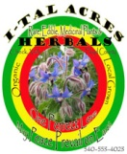 I-TAL ACRES Herbals - Lunar Organics
Rare, Edible, Medicinal Plants & Herbals
540-553-4023 www.italacres.com
Located in the Blue Ridge Mountains in Floyd County (Check, VA), I-TAL ACRES is a small family farm business dedicated to being the change we wish to see in the world. Nature provides - Abundantly. But nature is under assault. We all depend on plants. So, like our ancestors, we look to the plants for answers. Mortgages, possessions, and desk jobs were cathartically replaced by a tipi (followed by a cabin) on land in the mountains, growing our own food and medicine. In addition to the over 90 fruit trees, shrubs, canes, and vines we have planted in our food forest, we have seeded and cultivated over 115 different species of medicinal herbs, and graciously harvest many of the invasive ‘weeds’ that volunteer themselves freely around our land. We are plant people, using only plants and plant products as food and medicine. I-TAL Acres specializes in rare, edible, and medicinal plants; growing only heirlooms and open pollinated varieties, no F1 hybrids or GMOs. We seed, grow, and prepare all of our plants lunar organically for the benefit of the planet and all of her inhabitants. Our herbs have been mindfully cultivated and harvested at peak potency to serve as either wellness maintenance tonics or remedies for our family, friends, and community. We offer lunar organically grown medicinal herb plants from spring through fall, and can propagate many herbs upon request. We carry over 70 different potent home-grown vortexed tinctures, 7 healing salves and solar infused oils, all prepared with our own ital grown herbs and loving vibrations to help and heal all. Every product is created for our family, tested by our family, and approved by our family before making them available to your family and friends. These are the only medicines our children have ever used. While we do not diagnose or treat ailments, we are passionate about the human-plant relationship and making these amazing plants and their historical uses known and available at a very reasonable cost. We also offer our own line of bath and body products; from edible mineral toothpaste and mouthwash, to sugar scrubs and herbal deodorant, to aromatherapy sprays, chakra sprays and massage oils. For those looking for a flavor booster for pretty much anything, consider the sweet-heat of our Caribbean Fyah Sauce. A mango-habanero-scotch bonnet pepper sauce, made with our own ital grown hot peppers that compliments an amazing array of foods. We also offer our XXX HOT More Fyah Sauce; the same super flavorful base hot sauce with our own Ghost and Trinidad Scorpion peppers added! Please contact Maya or Ed with any questions or to arrange a visit. Plant more herbs, plant more trees. We are One Family. May Peace Prevail on Earth. May Peace Prevail Within. One Perfect Love.
What is I-tal (EYE-tal)?
Ital comes from the island of Jamaica, straight from the heart of Rastafari. Ital is Vital. Ital is Prana. Ital is Chi. Ital is organic. Ital is non-GMO. Ital is wild and free. Ital is holistic. Ital is non-linear. Ital is direct experience. Ital is infinite health. Ital is natural. Ital is vegan. Ital is sustainable. Ital is awareness. Ital is mindfulness. Ital is humility. Ital is gratitude. Ital is compassion. Ital is a positive vibration. Ital is infinite joy. Ital is spiritual oneness. Ital is absolute harmony. Ital is pure consciousness. Ital is profound love. Ital is divine wisdom. Ital is the Universe. Ital is your birthright. Ital is You!

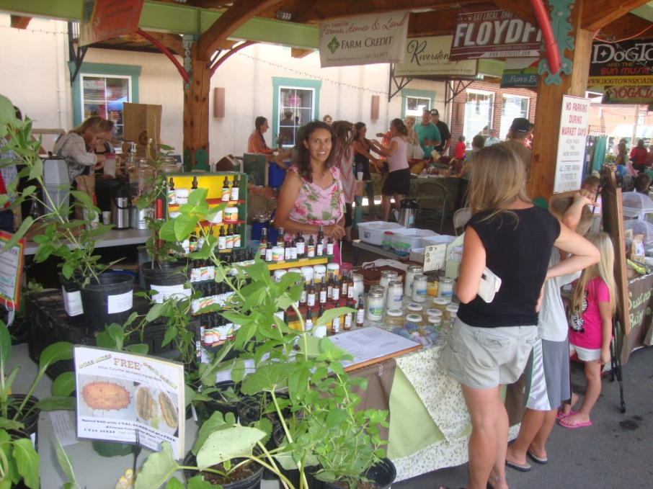
I-TAL ACRES - Lunar Organics
Rare, Edible, Medicinal Plants & Home Grown Herbals
We seed and grow all of our plants lunar organically for the benefit of the planet and all of Her inhabitants. All of our herbals are prepared with our own ital grown herbs and loving vibrations to help and heal all. We are One Family. May Peace Prevail on Earth. One Perfect Love.
Vortexed Tinctures 1 oz Dropper $9.50  Anemarrhena  Andrographis  Angelica  Arnica  Ashwagandha Root  Astragalus Root  Balloonflower  Basketplant  Bergamot  Bidens  Bitter Melon  Black Cohosh Root  Black Walnut  Blue Cohosh Root  Boneset  Borage  Bugleweed  California Poppy  Calamus Root  Catnip  Cat’s Claw  Cayenne  Celandine & Celandine Glycerite  Chameleon Plant (Houttuynia)  Chickweed  Cilantro  Cleavers  Dandelion  Echinacea  Elderberry  Elecampane Root  Epilobium  Evening Primrose  Feverfew  Ginkgo  Gravel Root  Ground Ivy  Goldenrod  Hawthorn  Horehound, White  Horsetail  Isatis Leaf  Japanese Knotweed  Lemon Balm  Lions Mane  Lobelia  Many of our tinctures available in 4oz droppers for $33. | Marshmallow  Meadowsweet  Melilot  Motherwort  Mugwort  Mullein  Nettle  Oats (Milky Stage)  Osha  Parsley  Passionflower  Pine Pollen  Plantain  Poke Root  Rabbit Tobacco  Red Clover  Reishi  Sarsaparilla  Schizonepeta  Self-Heal  Sheep Sorrel  Skullcap-Official  Solomon’s Seal  Spikenard  Spilanthes  Stevia (Whole Leaf)  St. John’s Wort  Stoneroot  Sumac (Staghorn)  Sweet Annie  Teasel  Thieves Ancient Secret  Tulsi (Holy Basil)  Turmeric w/ Blk Pepper  Usnea  Valerian Root  Viper’s Bugloss  Wild Lettuce  Wild Yam  Wood Betony  Wormwood  Yarrow  Yellow Dock Root  Yellowroot | Synergized Compound Tinctures 1 oz dropper $9.50  Lyme Support - (Japanese Knotweed, Cat’s Claw, Andrographis, Houttuynia, Ashwagandha, Spilanthes, Wood Betony, Tulsi)  DETOX – (Nettle, Vipers Bugloss, Cleavers, Dandelion, Chickweed, Epilobium, Isatis, Tulsi, Cilantro, Parsley, Goldenrod, Yellow Dock, Sheep Sorrel)  Wellness Maintenance – (Chickweed, Nettle, Dandelion, Tulsi, Plantain, Elecampane, Red Clover, Self Heal, Parsley, Jiao-gu-lan, Purslane)  Teeth & Gums – (Dandelion, Black walnut, Plantain, Cilantro, Self Heal, Spilanthes, Horsetail, Cinquefoil, Agrimony)  Immune Booster – (Elderberry, Elecampane, Echinacea, Tulsi, Usnea, Spilanthes, Cats Claw, Reishi, Jiao-gu-lan, Isatis)  Lung Support – (Balloonflower, Elecampane, Mullein, Nettle, Isatis, Usnea, Tulsi, Oats, Marshmallow, Turmeric, Angelica, Goldenrod, Houttuynia, Horehound, Lobelia, Boneset)  Cancer Support – (Dandelion, Nettle, Cleavers, Reishi, Red Clover, Tulsi, Turmeric, Oats, Sheep Sorrel, Ashitaba, Jiao, Andrographis, Poke Root, Celandine)  Pineal/Pituitary Support –(Vipers Bugloss, Nettle, Skullcap, Gingko, Passion vine, Shatavari, Rosemary EO)  Sleepy Time – (Passionvine, Valerian, Skullcap, Catnip, CA Poppy, Hops)  Parasite Cleanse – (Black Walnut, Wormwood, Clove, Elecampane, Spilanthes, Andrographis, Sweet Annie)  Hyperactivity Support – (Brahmi, Lemon Balm, Milky Oats, Passion, CA Poppy, Catnip, Wood Betony, Skullcap, Gingko, Knotweed, ITAL Detox, Jiao, Ashwagandha, Rosemary EO)  Hormone Support – (Black Cohosh, Pine Pollen, Passionvine, Red Clover, Nettle , Tulsi, J. Knotweed, Ashwagandha, Shatavari, Rehmannia)  Heart Tonic – (Hawthorn, Motherwort, Tulsi, Nettle, Cayenne, Andrographis, Jiao-gu-lan)  Migraine Headache – (Ferverfew, Wood Betony, Lemon Balm, Skullcap, Gingko, Meadowsweet, Valerian, Cayenne)  UTI Blend – (Goldenrod, Epilobium, Cleavers, Dandelion, Juniper, Uva-Ursi)  Hypothyroid Support – (Bladderwrack, Dandelion, Mint, Nettle, Ashwagandha, Boneset, Milky Oats, Black Walnut, Cayenne)  Adrenal Support – (Milky Oats, Vipers, Nettle, Borage, Motherwort, Lemon Balm, Skullcap, Ashwagandha)  Sinus Support – (Yarrow, Sumac, Wood Betony, Goldenrod, Cayenne, Goldenseal Leaf)  Musculo-Skeletal Support – (Dandelion, Horsetail, Solomon’s Seal, Teasel, Boneset, Wood Betony, Turmeric, Ladies Mantle, Arnica)  Allergy Assister – (Nettle, Schizonepeta, Angelica, Parsley, Turmeric, Tulsi, Bidens, Goldenrod, Wolf, Spikenard)  Asthma Support – (Nettle, Yarrow, Tulsi, Gumweed, Elecampane, Spikenard, Hyssop, Wolf, Angelica, Rabbit Tobacco, Lobelia, Goldenrod)  Mellow Mood – (Skullcap, St Johns, Reishi, Passion, Motherwort)  Pain Relief – (Wild Lettuce, Wood Betony, Indian Pipe, CA Poppy, Meadowsweet, Valerian, Skullcap, Ashwagandha)  Nerve Pain/Damage – (Lions Mane, St. Johns, Skullcap, Yarrow, Wolf, CA Poppy, Cleavers, Milky Oats, Wild Yam)  Spirit Animal Tincture Blends 1oz $9.75  Wolf Medicine (Agrimony/Cinquefoil)  Bear Medicine (Osha/Angelica)  Turtle Medicine (Gravel Root/Celandine)  Elk Medicine (Sumac/Bergamot/Gravel Root)  Rabbit Medicine (Red Clover/Nettle/Rabbit Tobacco/Skullcap/ Mugwort/Ground Ivy/Wild Yam)
Solar Infused Oil 1oz $9.75  Cleavers Oil  Comfrey Oil  Elder Leaf Oil  Rose Hip Oil  St. John’s Wort Oil  Poke Root Oil  Perineal Massage Oil  Ear-ache Oil $10.75  Toe Nail Fungus Oil $10.75  Salves 2oz Container  Chickweed Salve $11  Not Just For Babies $11  Wounds, Cuts, Burns Salve $11  Aches & Pains Salve $14  Black Drawing Salve $13  Poison Ivy Salve $13  Love the Skin You’re In $13  Baby Bump Butter $13  Body Butter $13  Aromatherapy/Massage Oil  Lavender Oil Blend 1oz $6  Peppermint Oil Blend 1oz $6  Patchouli Oil Blend 1oz $6.5  Calming Lavender- Chamomile Oil 1oz $7.75  Chakra – Third Eye Oil 1oz $8.75  Respiratory/Flu Oil 1oz $8.75  Menopause Aid Oil 1oz $10.75  Snoring Relief Oil 1 oz $8.75  Sugar Scrubs 8oz $9.75  Lavender  Lemongrass  Tension Tamer  Lip Balm .3 oz Container $3  Cocoa Coconut  Citrus Spice  Coconut Paradise | Salve Sampler  6 - .5 oz tins each of: Chickweed, Wounds, Aches &Pains, Love your skin, Black Drawing, and Poison Ivy Salve, comes with Jewelweed Soap | Baby Care  Happy Bums Diaper Spray 2 oz $4.75  Not Just For Babies Salve 2 oz $11  Calming Lavender -Chamomile Oil 1 oz $7.75  Perineal Massage Oil 1 oz $10.75  Baby Bump Butter 2 oz $13  ITAL Room & Body Mist Sprays 2 oz. $4.75  The Uplifter  One Love  Unity  Brain Power  Sweet Dreams  ITAL Chakra Spritzers 2 oz. $5.75  The Root Chakra  The Sacral Chakra  The Solar Plexus Chakra  The Heart Chakra  The Throat Chakra  Third Eye Chakra  The Crown Chakra  ITAL Mouthcare  ITAL Toothpaste 2oz $3.75, 4oz $6.50  Swishy Water Mouth Rinse 17oz $2.25  Happy Gums Mouthwash Tincture 4 oz $10  White Oak Bark – 2oz $3.50  *ITAL Herbal Tooth & Bone Tonic Tea *= special order  (re-mineralize teeth & bones)  Bentonite Clay, Food Grade 2oz $3  Deodorant  Herbal Deo 2 oz $4.75  Insect  ITAL Bug Spray 2oz $4.75  Drawing Salve 2 oz $13  Chickweed Salve 2oz $11  Jewelweed Soap $3.50  Kombucha Starter $15  Caribbean Fyah Mango Hot Sauce 5 oz $6 10 oz $10  XXX More Fyah GHOST & Scorpion Hot Sauce 5 oz $7  ONE PERFECT LOVE  NAMASTE - We Are One - Humanity Awakening
COMPASSIONATE PLANT ADVOCATES; HOWEVER, WE DO NOT TREAT OR DIAGNOSE.
Infinite Health, Infinite Happiness, Infinite Provision, Infinite Joy, Infinite Success, Infinite Light, Infinite Blessings, Infinite Love, Infinite Being

I-TAL ACRES
Cultivating Expansive Hearts and Open Minds
Let Your Food Be Your Medicine and Your Medicine Be Your Food
May Peace Prevail on Earth - One Perfect Love. Positive Vibrations.
Check, VA 540-553-4023 italacres.com

I-TAL ACRES - Lunar Organics
Rare, Edible, Medicinal Plants & Herbals
540-553-4023 italacres.com
At Ital Acres we are compassionate plant advocates; we do not treat or diagnose. Herbs do not treat symptoms; they are wellness tonics that help us restore balance in a hectic and often non-nutritive world. When energetics of individual and energetics of herbs are matched, wellness can be restored. “Sometimes the herbs work as the result of careful and purposeful application, while other times the mode of healing can only be attributed to the workings of a great mystery that is beyond our calculated comprehension…herbs grown by our hands in local gardens provide the strongest medicine we can possibly make and dispense to heal… we experience the value of maintaining a relationship with the medicine from the time the seed is dropped into the soil to the time the extract is filtered…I have an unshakeable faith in the medicine, and this provides a strong foundation for healing.” (Richo Cech, Making Plant Medicine) Most of our preparations are homegrown, from seed, to harvest, to herbal remedy; others are locally wildcrafted. Cat’s Claw is our only imported or purchased herb. Most herbs have many different uses. Following are some historical folk uses of several different herbal preparations. For educational purposes only, not approved by FDA. We do not treat/diagnose.
Tinctures – an herbal extract produced by steeping ground herb in a liquid menstruum (usually alcohol), infusing (and preserving) the liquid with the active constituents of the herb. Dosage - A few drops to droppersful mixed in water, juice, or tea, depending on the herb.
Anemarrhena – Pneumonia, Bronchitis, Cough, Fever, Rapid Pulse, Dizziness, Reduce Blood Sugar, Antibacterial, Kidneys Andrographis - Lyme & Systemic Infections, Gastroenteritis, Sluggish Digestion, Liver stimulant
Angelica – aromatic bitter, improve digestion, colic, PMS, cramps, break fever, cold/flu symptoms, asthma, UTI, rheumatism, anti-inflammatory, pain relief, anti-bacterial
Arnica – Anti-inflammatory for traumatic injury, relieve pain & bleeding post-op, strengthen nerve force, improve weak circulation, urinary incontinence, spiritual & emotional trauma
Ashwagandha – energy building, adaptogenic, sexual tonic, senility, burnout, lack of focus, headache, infertility/low sperm count, aphrodisiac
Astragalus Root – Immune system stimulant, blood building, anemia, weakness, poor appetite, liver aid, builds energy and stamina, post chemo/radiation
Balloonflower – expectorant, breaks up phlegm/mucus, bronchitis, anti-inflammatory, gastric issues, immune stimulant, lower bad cholesterol, tumors/cancer, liver flukes/parasites, analgesic/pain relief, anti-allergenic
Bergamot – powerful antibacterial, antiseptic, anesthetic; sore throats/colds; female reproductive tonic, regulates menses; urinary tract infections both bacterial and yeast; anti-anxiety, calms nerves
Bidens – Antibiotic, Antibacterial/microbial, Antimalarial, Staph, Babesia, Hepataprotective, Neuroprotectant, Systemic Infections Bitter Melon – best anti-diabetic herb known; supports pancreas and promotes secretion of insulin
Black Cohosh Root – PMS/Menopause, rheumatic & aching body pain, tinnitus, anti-depressant
Black Walnut Green Hulls – Parasites, Anti-viral, Anti-bacterial, Anti-fungal, Laxative, Digestion, Spleen Pain, Cavities
Blue Cohosh Root – premier uterine tonic, assist labor/delivery, delayed menses, excessive flow, cramps & pains, anti-spasmodic, rheumatic pain
Boneset – Immune stimulant, flu/cold/pneumonia/respiratory problems, fever with aches and pains, malarial chills, bitter, improve appetite, digestive aid
Borage – Adrenal tonic, calm body/mind, anxiety, fever, post-surgery/steroids, lifts spirits, anti-inflammatory
Bugleweed – Hyperthyroidism, Graves disease, heart tonic, heart disease, cough, bleeding stomach or lungs
Calamus Root – general stimulant and antispasmodic, indigestion, gastro-intestinal tonic, gastric ulcers, flatulent colic, sharpens memory from burnout and senility
California Poppy – Pain reliever, calming sedative, anxiety, restlessness, toothache, headache, body aches, mild enough for children and elderly
Catnip – sedative, insomnia, headache, fever, anti-spasmodic for gas/indigestion, mild and specific for infant colic, delayed menses
Cat’s Claw – Our only imported/purchased herb. Organically grown in the Amazon. Adaptogenic immune booster, IBS, diverticulitis, intestinal problems, arthritis, allergies, herpes, Lyme, Crohns, chemo, tumors, antimicrobial
Cayenne – strengthen heart muscle, increase circulation, normalize blood pressure, digestion, travel diarrhea, cold extremities, ward off disease, prophylactic against cancer
Celandine – Alterative; immune builder, debilitating disease, liver stimulant, gastro-spasm, free up and disperse toxins, prophylactic against cancer
Celandine Glycerite – used externally on warts, corns, skin growths, tumors
Chameleon Plant – broad-spectrum anti-viral and anti-bacterial, dengue, bird flu, zika, west nile, mycoplasma, herpes simplex, UTI, candidiasis, detoxify, reduce swelling, lung infections, Lyme, Bartonella, cancer
Chickweed – Nourishing tonic, improve energy levels, alkalizing effect on blood, treats hyperacidity, speeds fat metabolism, weight loss programs
Cilantro – sharpens appetite, promotes flow of bile, draws heavy metals from teeth, bones, CNS, body tissues
Cleavers – lymphatic cleanser, blood purifier, urinary infection, urinary stone, prostatitis, external dilution for poison ivy, sunburn, skin problems
Dandelion – blood cleanser, detoxifier, promotes liver function, bile secretion, arteriosclerosis, indigestion, bad skin, diuretic, helps re-calcify teeth and bones, cancer
Echinacea – Immune stimulant, helps with bacterial and viral infections, colds/flu/respiratory infection
Elderberry – Immune stimulant, anti-viral, upper respiratory infection, flu/fever/colds
Elecampane – premier treatment for upper respiratory tract, cough, colds, TB, flu, parasites, asthma, bacterial, viral, and fungal infections
Epilobium – specific for benign prostatitis, diuretic, detox and normalize urinary tract, astringent, urinary swelling, dysfunction and pain, diarrhea
Evening Primrose – migraines, pelvic fullness, PMS, Menopause, Tonify Female Organs, Indigestion, Diarrhea
Ginkgo Leaf – Immune stimulant, anti-inflammatory, vasodilator, increased blood oxygen, improve memory, tinnitus, asthma, heart & kidney disorders
Gravel Root – Tonify/Cleanse Genito-urinary tract, Stones, Kidneys, Prostatitis, Balance Bodily Fluids, Remineralize, Deposits in Joints
Ground Ivy – Lung Ailments, Fever, Edema, Anti-inflammatory, Antioxidant, Leukemia, Lung Carcinoma, Kidneys
Goldenrod – soothing tonic for genito-urinary tract, kidney and bladder infections, antiseptic, diuretic
Hawthorn – heart tonic, heart surgery, heart attack, degenerative heart disease, weak heart, irregular heartbeat, regulates blood pressure, promotes open-hearted well-being
Horehound, White – upper respiratory tract, suppress cough, promotes expectoration, colds, gentle laxative and digestive bitter, delayed menstruation
Horsetail – source of bioavailable silica and nutrients, bones, teeth, hair, skin, joints, ligaments, connective tissue, spine, osteoporosis, collagen synthesis, aluminum detoxifier
Isatis – antibiotic, antiviral, antiseptic, antimicrobial, antiparasite, anticancer, anti-Inflammatory, leukemia, SARS, HIV, flu, mumps, fever, strep/staph, blood poisoning, food poisoning
Japanese Knotweed – adaptogenic immune modulator w/ resveratrol, Lyme, Calms CNS, antibiotic, anti cancer, antioxidant, antibacterial, hypertension, arthritis
Juniper Berry – one of best UTI antiseptics, inflammation of kidneys, bladder, urethra, frequent/burning urine
Lemon Balm – overexcited children, ADHD, gentle sedative/calming, colds, fever, adult nervousness, longevity
Lion’s Mane (Mushroom) – Cognitive Enhancement, Protect Brain Cells, Increase Nerve Growth Factor, Mood, Stress, Depression, Anxiety, Immune Booster, Anti-Oxidant, Dementia, Alzheimers, Parkinsons, Nervous system damage
Lobelia – premier expectorant and anti-spasmodic, helps chronic coughs and lung problems, low dose botanical – emetic at high dose
Marshmallow – nutritive, immune enhancing, inflamed mucous membranes, colds, coughs, UTI, upper respiratory tract, gastric/duodenal ulcer
Meadowsweet – herbal aspirin, pain reliever, anti-inflammatory, headache, muscle pain, fever, cold, flu, astringent, helpful for infant diarrhea
Melilot – Vascular Congestion, Thrombophlebitis, Hemorrhoids, Blood Thinner, Digestion/Overeating/Gas, Leg Cramps, Spider Veins Motherwort – strengthens and regulates heartbeat and hyperactive thyroid, promotes regularity of menstrual cycle, nervine tonic
Mugwort – digestive stimulant, bloating, gas, cramps, anti-microbial in gut, travel sickness, gastric issues, worms, nervous disorders, insomnia, lucid dreams/dream recall
Mullein – demulcent for upper respiratory tract, expectorant, coughs, sore throat, bronchitis, mild sedative, diarrhea
Nettle – blood builder and cleanser, nutritive tonic, bolster entire body, improve resistance to allergies (mold, pollen, pollutants)
Oats (Milky) – nervine tonic, exhaustion, sleeplessness, adrenal burnout, addiction to nicotine, caffeine, drugs; diuretic
Parsley – highly nutritive, detox, heart health, anti-cancer, liver conditions, soothe kidney, kidney stones, gallstones, gout, digestive stimulant, colds, UTI, anemia, hay fever, immune booster, diabetes
Passionflower – nervous restlessness, insomnia, sedative, slows pulse, painful menses, headache, antispasmodic, lessens nerve pain
Pine Pollen – nutritive tonic, adaptogenic master rejuvenator, vitality, immune/endocrine function, anti-inflammatory, balance androgen/estrogen ratio, menopause, cancer, libido, prostate
Plantain – alterative, antiseptic, astringent, infections, toothache, diarrhea, cough, skin problems, acne, eczema
Poke Root – lymphatic stimulant, cleanse blocked glands, catarrh, tonsillitis, laryngitis, swollen glands, respiratory infection, mumps; low dose botanical
Purslane – nutritive, vitamin rich, highest terrestrial source of Omega 3s, digestive and urinary tonic, fevers, sunstroke
Rabbit Tobacco – Coughs, Asthma, Colds, Bronchitis, Mild Sedative/Pain Reliever, Skin Sores, Burns, Aphrodisiac Red Clover – blood thinning alterative; remove metabolic waste, prohibit attachment/metastasis of abnormal cells; prevention/treatment of cancer; menopause; normalize BP, cholesterol; promotes youthfulness
Reishi Mushroom – boosts immune system, fights tumors, anti-oxidant, lowers blood pressure and cholesterol, anti-allergenic, improve liver and respiratory function
Schizonepeta – supreme anti-itch, antihistamine, skin problems, antimicrobial, anti-inflammatory, sore throat, fever, mastitis, measles, carbuncle; palate and Ear, Nose, Throat itchiness
Self-Heal – general body tonic, healing astringent, specific for oral and genital herpes, canker sores, wound wash, sore throat gargle
Sheep Sorrel – degenerative disease, bacterial infection, parasites, cancer, detox/tonify organs/tissues, inhibits proliferation of abnormal cells, rids body of endotoxins/metabolic waste, loaded with vitamins/trace minerals
Skullcap – nervine tonic, sedative, anti-spasmodic, nerve pain, stress, insomnia, tremors, nervous agitation, hysteria
Spikenard – adaptogenic, energy, stress, affinity for upper respiratory, lungs, digestive, reproductive organs
Spilanthes – Immune, lymphatic, circulatory stimulant, bacterial and viral infections, blood parasites, spirochetes, Lyme, oral anti-septic, toothache, thrush, impetigo, cold sores
Solomon’s Seal – broken bones, sprains, injured tendons and ligaments, tendonitis, arthritis, dryness in joints and "slipped"/herniated discs, moisten connective tissue and lubricate joints, expectorant, coughs, intestinal inflammation
Stevia – normalize hypoglycemia, digestive aid, sweetener, astringent wound healer, anti-microbial, Lyme, Borrelia
St. John’s Wort – deep seated nervine, restore nerve tissue, assist nerve pain, chronic disease, anti-depressant, help urinary organs
Sweet Annie – clears parasites from blood, malaria, headache, nausea, fever, chills, leukemia, non-small-cell lung cancer
Teasel – Lyme, Inflammatory issues, pain, conditions of stagnation, musculoskeletal problems
Thieves – immune stimulant, bacterial and viral infections, cold/flu/respiratory infection
Tulsi (Holy Basil) – Immune stimulant, expectorant, flu, indigestion, stress, bronchitis, sharpens the mind, normalizes blood pressure and blood sugar, prophylactic against cancer, prostatitis, malaria
Turmeric – anti-inflammatory, anti-tumor, antioxidant, antimicrobial, stomach pains, kidney inflammation, cystitis, colds, fever, bronchitis, worms, chest infections
Usnea – herbal antibiotic, anti-bacterial, immune tonic, staph infections, strep, bronchitis, pneumonia, colds, fatigue, sinus, kidney, bladder, lung, yeast infection
Valerian – nervine tonic, sedative, induce sleep, reduce stress and tension, pain reliever, anti-spasmodic, cramps, intestinal colic, nervousness, irritability
Viper’s Bugloss – draws venom, poisons, toxins, heavy metals; fevers, headaches, lung and chest conditions, colds, inflammation, nervous complaints, melancholy, Solar Plexus
Wolf Medicine – Wolf is the leader of the pack, helps thru changes in life/changes the environment around you; physical/mental tension, pain, liver/kidney congestion, hepatitis, intestinal tonic/detox, gout, healing astringent, teeth
Wood Betony – nervine tonic, pain reliever, panacea, nerve pain, toothache, headache, wounds, recovery from chronic disease or addiction
Wormwood – general anti-parasitic, de-wormer, digestive bitters, improve appetite and digestion, tooth decay, tonify stomach and gallbladder
Yarrow – hemostatic, antiseptic for bleeding, deep wounds, bitter tonic, anti-spasmodic, improve digestion, colds/fevers, tonify skin
Yellow Dock – blood cleanser, iron deficiency, constipation, menstruation, dispels toxins, improve skin
Herbal Infused Oils – herbs are steeped in EVCP Olive oil for a period of time under gentle heat (solar) to extract medicinal compounds from the herbs…used externally, massaged onto skin, absorbed into body
Cleavers – swollen glands, skin growths, tumors, to clear up complexion
Comfrey – sprains, broken bones, bruises, sore muscles, shallow wounds
Elder Leaf – traumatic injuries, old burns, ulcerations, hemorrhoids
Rose Hip – wrinkles, stretchmarks, scars, sunspots, hair, rosacea, rash
St. John’s Wort – nerve pain, sprains, bruises, pulled muscles, burns, hemorrhoids
Poke Root – lymphatic blockage, swollen glands, neck, underarm, groin, breast
Ear-Ache – for earache, pain, infection, discomfort, swimmers ear
Toe Nail Anti-Fungal Oil – For athlete’s foot, yellow toe nails, jock itch, ringworm, fungal rash
Salves – infused herbal oils, coconut oil, beeswax, and essential oils….massaged onto skin for herbs to penetrate tissues
Aches and Pains – arthritis, muscle aches/pains, bumps and bruises, breaks, sprains, sports injuries
Black/Drawing – anti-septic, draws out toxins, tick bites, splinters, venomous bites, any bad insect bite
Chickweed – rash, itching, eczema, stings, insect bites, wounds
Love the Skin You’re In – tonify and beautify skin, scars, stretch marks, wrinkles, skin problems
Not Just For Babies – rashes, bumps, cuts, stings, itching, flaking, peeling, burns, bites, bruises
Poison Ivy Salve – formulated for relief of poison ivy, poison oak, etc…though useful for itching, bites, rash
Wounds, Cuts, Burns Salve – for deep cuts, shallow cuts, puncture wounds, scrapes, abrasions, lacerations, burns
Aromatherapy and Chakra Sprays
The Uplifter – blend to uplift your mood and increase energy
One Love – blend to bring light to the darkness, soften the heart, and find peace in hectic world
Unity – blend to unite heart and head, male and female energy, to calm and center, and move from judgment to generosity
Sweet Dreams – blend to calm, relax, and prepare for sleep
Brain Power – blend for mental clarity, focus, memory recall
The Root Chakra Spritzer – blend to help balance and restore the Root Chakra; to help feel grounded, centered, and secure
The Sacral Chakra Spritzer – to help balance and restore the Sacral Chakra; help with assimilation of nourishment and acceptance of new ideas
The Solar Plexus Chakra - to help balance and restore the Solar Plexus Chakra; help balance energy in relationships and wise decision making
The Heart Chakra Sprizter – blend to help balance and restore the Heart Chakra; to help give & receive love; to cope, endure, and rise.
The Throat Chakra Spritzer - to help balance and restore the Throat Chakra; help with communication, will-power, and self-expression
Third Eye Chakra Spritzer – blend to help balance and restore the Third Eye Chakra; Trust in Self
The Crown Chakra Spritzer – blend to help balance and restore the Crown Chakra; to help influence a deeper spiritual understanding of the Self

This information is for educational purposes only; not approved by FDA nor do we approve of FDA. We urge you to learn more about these and all herbs; Consult herbal books, herbalists, the herbs themselves, internet sites, and mostly, deep within. Be the awareness. We do not treat or diagnose.
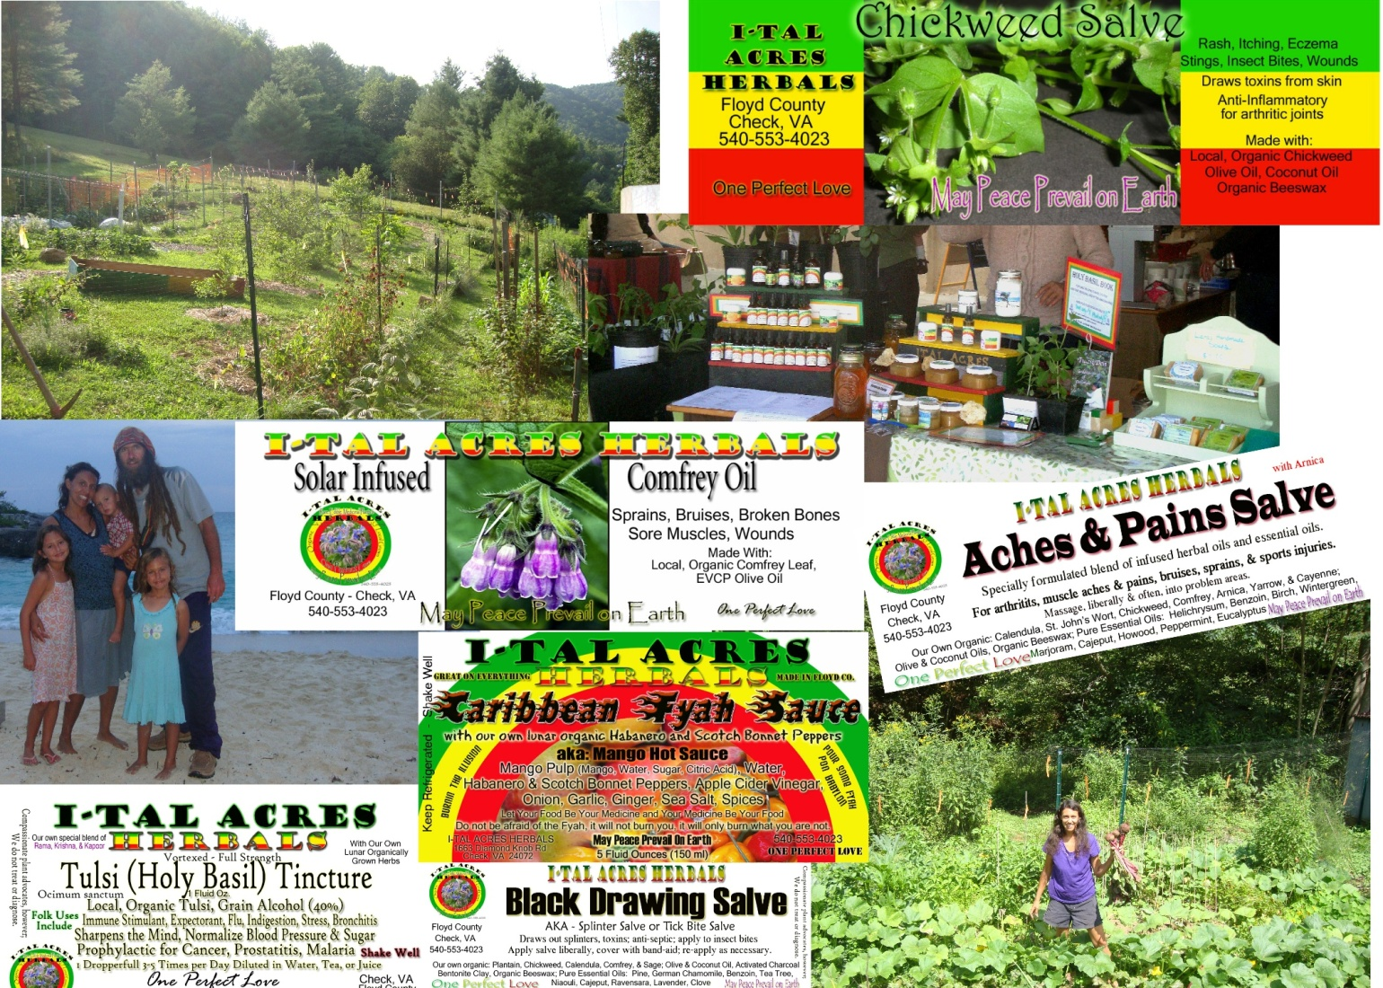
Infinite Health, Infinite Possibilities, Infinite Blessings, Infinite Happiness, Infinite Joy, Infinite Light, Infinite Love, Infinite Being.
WE ARE ONE.
ONE PERFECT LOVE.

I-TAL ACRES
Cultivating Expansive Hearts and Open Minds
Let Your Food Be Your Medicine and Your Medicine Be Your Food
May Peace Prevail on Earth - One Perfect Love. Positive Vibrations.
Check, VA 540-553-4023 www. italacres.com

